Public Perception of Pneumonia Messages on Social Media: A Study of Jos North and Jos South Local Governments in Plateau State, Nigeria

LAMAI, Ochanya Mercy
Department of Mass Communication
Nasarawa State University, Keffi
ochilamai.ol@gmail.com
07035968803
Abstract
The focus of the study is on public perception of social media agenda setting on pneumonia ailment in in Jos South and Jos North Local Government Areas of Plateau State, Nigeria. Survey research was used with questionnaire as the instrument of data collection. Unified Theory of Acceptance and Use of Technology (UTAUT) were used to explain the theoretical aspect of the study. The estimated population was of the two local government areas is 1, 101, 300. The sample size used for the study was 300, which were purposively selected. Findings revealed the most used social media among the studied population are WhatsApp and Facebook. The study also found that the type of pneumonia messages that the respondents received from Facebook, WhatsApp, Tiktok, Twitter and Instagram include messages that pneumonia causes cough, fever, chills and difficulty in breathing, chest pain, confusion or changes in mental awareness, and fatigue. Others are sweating and lower than normal body temperature. Others are sweating and lower than normal body temperature, nausea, vomiting or diarrhea and new born and infants may not show any sign of the infection. The study also revealed that the messages the respondents get from the studied social media include get vaccinated to prevent the disease, ensuring that children get vaccinated, practice good hygiene, stop smoking, and keep your immune system strong by sleeping enough, doing exercises regularly and eating healthy diet. It was recommended among others that governments and its agencies should create social media platforms sorely for enlightening the people about the scourge of pneumonia.

Keywords: Social media, perception pneumonia, messages.

Introduction
Pneumonia, which is a form of acute respiratory infection that affects the lungs, was first discovered in 1881 by French microbiologist, Louis Pasteur and American microbiologist, George Sternberg (World Health Organisation, 2022 & News Medical and Life Sciences, 2023), remains one of the public health issues globally. According to Clinic Barcelona (2021), pneumonia is responsible for 2.5 million deaths each year across the globe. For instance, data from the British Lung Foundation (2023) indicates that in 2004, in every 100, 000 people diagnosed in the United Kingdom, 307 were found to be having the disease. In 2009, for every 100, 100 check, 409 people had the ailment. 2012 statistics show that for every 100 000 people, 345 had pneumonia issues (British Lung Foundation, 2023). Further, according to information obtained from the Office of National Statistics (2021), in 2020, 19, 642 people died from complications related to pneumonia across England and Wales. News Medical and Life Sciences (2023) claims that each year more than 25, 000 people die from pneumonia in the UK.

According to Centres for Disease Control and Prevention (2021), in the United States of America (USA), in 2018, 1.5 million Americans were diagnosed with pneumonia, and out of these figures, 40, 000 of them died as a result of the ailment, with the adult population the most affected. In 2019, there were more than 1.3 million cases of pneumonia with over 50, 000 deaths (Lipper et al, 2022). In the same vein, figures from UNICEF (2022) reveal that world-wide, in every 100, 000 children, there are more than 1, 400 cases of pneumonia, or 1 case per 71 children annually, emphasising that South Asia accounts for about 2, 500 cases per 100, 000 children with West and Central Africa having 1, 620 incidences per 100, 000 children. For instance, India is said to account for 23% of global incidences of pneumonia with the death rate fluctuating from 14 to 30% (Sharma, 2023); while Bangladesh contributes over half of the world’s pneumonia cases in children under 5 years old, and in 2016, more than 1.87 million pneumonia cases were reported in the country (Brooks et al, 2021).
Furthermore, in Kenya, a study by Tornheim et al (2007) reveal that in Bondo District a total of 2, 466 patients were diagnosed with pneumonia with 282 deaths between 2001 and 2003. The incident peak was put at 698 per 100, 000 people under 5 years of age and those under 20 to 29 years, the incident peak was 356 per 100, 000 persons.
Another statistics indicates Kenya in 2018 was among the top 15 countries having the highest number of pneumonia cases and the country contributes about 74% of global pneumonia incidences in 2018 (Machuki et al, 2019). Ghana has also had it fear share of the pneumonia disease. According to records, the country in 2020 recorded a total of 16, 262 or 9.29% of fatalities. The age adjusted death rate is 99.08% per 100, 000 of the population and Ghana is ranked 26 globally (WHO, 2020). Similar, according to UNICEF (2019), Nigeria contributes the highest number of deaths related to pneumonia world-wide in 2018. The estimated deaths mostly children was put at 162, 200, with over 443 fatalities daily (UNICEF, 2019). Another data by Muanya (2020) shows that between 142, 000 and 160, 000 fewer than 5 Nigerian children die annually due to complication from pneumonia.
In Nigeria, Plateau State is among the states with highest number of pneumonia cases. And it is on this note that this study is situated in Plateau State, Nigeria (Adama, 2017). One of the public tools used to contain the spread of ailments is the mass media. The mass media according to Collins et al. (2003) plays the role of change agent. It can influence the behaviour of people for the sake of better health by adapting to preventive measure which stops the spread of diseases. By informing and educating about different health issues, media help promote healthy lifestyle and positive behaviour changes among the common public. USAID (2006)), affirms that the media is an important ally in any public health situation. It serves the role of being a source of correct information as well as an advocate for correct health behaviours. But before the media can take on that role, it needs to understand the virus, the issues surrounding it, policy and practices, and finally, recommended correct behaviours.
The social media over the years has become one of the most used communication means among people across the world. It is used to disseminate health-related information. A study by Mohammed et al (2021) concludes that health educators and students in Saudi Arabia have been using the social media to spread health-related messages with a view to educating and raising the awareness of the people around them on various ailments. Goldstein et al (2013) aver that “Healthcare providers and patients increasingly turn to the Internet—websites as well as social media platforms for health-related information and support” (p.2). In the same vein, Laranjo et al. (2015) established that social media platforms stand for an indispensable communication supply that enables creating and circulation of messages to people across the globe through the instrumentality of the World Wide Web. It is imperative to assert here that social media tools give groups and individuals the opportunities to share information concerning all issues in the society and to mould and form their views on such matters. Dubey et al. (2016) opined that health information and perspectives pertinent to human health issues are revealed informally using social media platforms away from medical officials and health departments.
Deducing from the above, it is safe to assert that since the social media are communication platforms that the people access information anytime and anywhere they are, there is the tendency that the people will be more aware of various diseases, one of which is pneumonia. Thus, the focus of this research is to find out the extent to which social media set the needed agenda on pneumonia ailment, with a focus on residents of Jos North Local Government Area in Plateau State, Nigeria.
Problem Statement
The characteristics of the social media make them one of the fastest and easiest ways of sending and information about health-related issues. For instance, Abuhashesh et al (2021) contend that social media was massively used by health professionals, health organisations, and even the general pubic in the dissemination of messages on COVID-19. Merchant and Lurie (2020) established in their study that as a result of the use of social media, varieties of channels to reach the public with health information are available. Though they are referred to as fast and efficient in disseminating health messages, they could sometimes be misleading. Yigitcanlar et al. (2020) avert that, health experts during a pandemic usually employ the use of the social media to understand public perceptions and what they want. In addition, La et al. (2020) concur further that during the COVID-19, a lot of nations and countries hid information about the disease, but the social media was there to bridge this information denial.
Thus, the focus of this study is to assess public perception of social media agenda setting on pneumonia disease among residents of Dadin Kowa, Zaramaganda, Rayfield and Bukuru in Jos South, and those residing in Babale, Tudun Wada, Laranto and Jenta Adamu in Jos North L.G.A. of Plateau State, Nigeria. This is the gap that this study filled.
Objectives of the Study
The broad aim of the study is to examine public perception on pneumonia disease. The specific objectives are to:
- Find out the types of social media the respondents used to access pneumonia messages.
- Examine the types of pneumonia messages they receive from the social media.
- Assess the extent to which residents of Jos South and North L.G.A. access messages on pneumonia on social media.
- Investigate whether social media messages on pneumonia have improved their knowledge of preventing and managing the scourge.
Scope of the Study
Beginning with the population of the study, it was targeted at residents of Dadin Kowa, Zaramaganda, Rayfield and Bukuru in Jos South, and Babale, Tudun Wada, Laranto and Jenta Adamu in Jos North Local Government Areas of Plateau State, Nigeria. The choice of these areas was due to the fact that pneumonia disease is common in Jos due to the cold weather. Further, the social media platforms used for the study were Facebook, WhatsApp , Instagram, Twitter and TikTok. The justification for choosing these social media platforms was because they are most used among residents of Jos North and South L.G.As.
Review of Literature
Pneumonia
According to the World Health Organisation (2022), pneumonia is a form of acute respiratory disease that is caused by bacteria or fungi which affects the lungs. It is an inflammation and fluid in human lungs caused by bacterial, viral or fungal infection; it causes difficulty in breathing and it signs and symptoms include fever, cough with yellow, green or bloody mucus (Cleveland Clinic, 2022). Mayo Clinic (2020) describes pneumonia as a disease that inflames the air sacs affecting one or the two lungs in humans and that the symptoms of the ailment include chest pain during breathing or coughing, confusion or changes in mental awareness, fatigue, low in normal body temperature, vomiting or diarrhoea and shortness of breaths.
Social Media
Social media are new forms of media that involve interactive participation. Apuke (2016) affirms that social media have expanded the horizon of communication and made the world smaller and communication process more rapid. As a new media, social media is a powerful tool for communicating rapidly without intermediary gatekeepers to spread new ideas (Schwab, 2015). Technological changes have facilitated in this direction and it is representing a prerequisite for changing society (Evans, 2011). Kaplan and Heinlein (2010) define social media as "a set of Internet-based applications that build on the conceptual and technological foundations of Web 2.0 and that allow the creation and exchange of user-created content". "Social media are web-based tools of electronic communication that allow users to exchange information individually or in groups, share ideas and opinions, make decisions and create, store, retrieve and exchange information because of its ability that allows the recording and manipulation of (text, images, videos, etc.), by anyone in the virtual world (Suchidipata and Saravanan, 2016). These personal profiles can then be connected with family, friends and colleagues, where information can be shared among one another. These connections create a network of users where anyone connected to the network can view everyone else’s profile and, therefore interact with them (Boyd and Ellison, 2007).
Furthermore, social media are systems of networks and applications that use the Internet to create a website which is then linked through an electronic social system with other members who have the same concerns (Sánchez-Moya & Cruz-Moya, 2015). This process is conducted through several services such as direct contact between people, sending messages and browsing personal pages for friends to see their news and some information about them (Choi, Panek, Nardis, & Toma, 2015). These networks contribute to an increased interaction and communication between users in the virtual community who are divided into groups of their own (Mariam, Nurazmallail & Miftachul, 2020).

The Role of Social Media in Health Communication
It is an established fact that social media is a web networking platform that allows people to reach each other with messages of various kinds (Batrinca & Treleaven, 2015). Social media tools make it easy for people across the globe to pass information in a quick manner. Social media has changed the way people communicate with each other, and this includes messages concerning health (Albarran, 2013). Dredze (2012) notes that through the instrumentality of the social media, humans do pass information on Twitter for instance, share health-related tips and look for remedies concerning any ailment from the social media. The healthcare sector, covering medical centres, health regulations, hospitals, professional associations, pharmaceutical corporations, and patient support groups, employs social media for numerous objectives. According to Jane et al (2018), social media is an emerging field of investigation in terms of health promotion, and it provides a cost- effective tool, thus there might be a valuable outcome of people or caregivers engagement in this online environment for healthcare purposes.

Moorhead, et al, (2013) affirm further that social media serves a great assistance to healthcare practitioners and those who access health facilities for treatment as it facilitates sharing of information between them. (Salathe, 2016) corroborates that health messages on social media environments of recent has been increasingly sent from internet-enabled tools, which provides the chance to carry geographic statistics. Shaw et al (2017) study established that the high extent use of social media by health professionals assist in the sharing of messages in real time which might lead for improved medical results, and the effective employment of the social media tools appreciably reduce the challenges might be raised in the conventional healthcare facilities (Hazzam&Lahrech, 2018). The platforms such as Facebook, YouTube, Instagram and Twitter have improved healthcare by enabling users to take a much more active and knowledgeable role in managing their personal health (The Star Online, 2019). Adams and Anantatmula, 2010) contend that medical descriptions are more beneﬁcial, and social media tools permit data to be presented in various forms. For example, videos on YouTube can be adopted as a substitute for written messages in the ﬁelds with low knowledge rates, where individuals cannot read medical records. Similarly, a difference of other forms of social media is related to motive debating between patients and comfort specialists (Shrank, 2011). These social media platforms are made up of Twitter, Myspace, Blogs, Wikipedia, and Email, asides Facebook that is managed on a wide-ranging extent to spread medical materials referred to epidemics, clinics, drugstores, and examination by the diseased person and health specialists (Farmer et al, 2020). Studies equally attested to the fact that in spite of the difference of interests of using social media among people, they still use them to get health information in a collective basis. Alkhateeb, Clauson, and Latif (2011) revealed that pharmacists’ intense use of social media is to enlarge their scope instead of using it for than for the professional advancement, as well the increasing adoption of social media among doctors which is utterly for personal and reference purposes (Von Muhlen& Ohno-Machado, 2012). The bottom line is that the new media platforms have altered the way stakeholders in various fields including health practitioners share information today.
Review of Empirical Studies
Ekure et al (2013) researched on mothers and childhood pneumonia: What should the focus of public campaigns be? The study described Nigeria as one of the territories with the highest members of pneumonia. It made use of the survey research and obtained data through the questionnaire instrument from mother who patronise paediatric clinics of the Lagos University Teaching Hospital. The study found that 15% of the mothers had no knowledge of pneumonia. More than half of those who participated in the research identified difficulty in breathing as one of the signs/symptoms of pneumonia. Three-quarters of the respondents said that they were aware of the causes of pneumonia to include cold. While to prevent pneumonia, 75% of the respondents alluded that it was through putting on of warm clothes. The study concluded that there was low knowledge of pneumonia ailment among mothers in Lagos State. It was suggested that efforts should be intensified to raise awareness about the disease among the public, by focusing on the immunisation, germs, hand washing and exclusive breastfeeding.
However, the work of Ekure et al (2013) dwelt on raising public awareness about pneumonia, particularly mothers in Lagos State. Their study did not examine the extent to which social media set the needed agenda on pneumonia ailment, with a focus on residents of Jos North Local Government Area in Plateau State, Nigeria.
Social media use as health awareness tool: a study among healthcare practitioners was the thrust of Majali et al (2021) study. The objective of the study was to identify conceptual framework for social media adoption by Malaysian healthcare practitioners (MHPs) as a health platform promoter in Malaysia. The study adopted the unified theory of acceptance and use of technology (UTAUT). The research discovered that the factors making people to accept the use of social media as a healthcare promotion platforms included Performance Expectancy, Effort Expectancy, Social Influence, and Facilitating Condition. As a way forward, it was suggested that to perform optimally as a healthcare professional, there was the need to disseminate trusted health message through these platforms. While the crux of Majali et al study (2021) was on social media and health awareness in Malaysia, the present study close this gap by focusing on the agenda that social media has been setting concerning pneumonia disease among people in some selected Local Government Areas, Plateau State, Nigeria.
Abuhashesh et al (2021) study was on “The Role of Social Media in Raising Public Health Awareness during the Pandemic COVID-19: An International Comparative Study”. Quantitative research strategy was used to obtain data, through the deployment of exploratory and descriptive research design. Results of the research indicated positive links between messages from the social media and public awareness and adoption of the messages regarding use of face masks, hand-washing, no touching of nose, eyes etc during the COVID-19 pandemic in two countries. It was further found that there were preferences in the kinds of social media tools, messages and the sources of information among the studied population as a result of differences in countries and territories. It was concluded that for health information to be effective, authorities in different countries should embrace the use of the right type social media and the kind of messages they disseminate.
In conclusion, effective and timely health communication is always essential, and this works via public health authorities’ use of social media platforms with an appropriate type of message and an appropriate source of message. The study recommended that public health authorities must continue their efforts to raise public health awareness by disseminating brief messages to targeted populations. However, sometimes it is crucial to reach every citizen in society. It was also suggested that for efforts to achieve their desired results, the public must reciprocate these efforts by practicing what is communicated by authorities of countries through the various types of mass media.
Further study is needed to ascertain the agenda that social media has set concerning pneumonia disease. Hence, the current study filled this gap by studying public perception of social media agenda setting regarding pneumonia ailment, focusing residents of Dadin Kowa, Zaramaganda, Rayfield and Bukuru in Jos South, and those residing in Babale, Tudun Wada, Laranto and Jenta Adamu in Jos North L.G.A. of Plateau State, Nigeria.
Theoretical Framework
The study is supported by Unified Theory of Acceptance and Use of Technology (UTAUT). The unified theory of acceptance and use of technology (UTAUT) is a technology acceptance model formulated by Venkatesh, et al (2003). The UTAUT model combines several user acceptances models such as the theory of planned behaviour theory of reasoned action, technology acceptance model, and innovation diffusion theory into one combined theory, this variety of perspective would result in more accurate and concise explanation of adoption due to the different characteristics of social media compare to other technology. The theory aims to explain user intentions to use an information system and subsequent usage behaviour. The theory holds that there are four key contrasts, which are performance expectancy, effort expectancy, social influence, and enabling conditions. The theory can be applied in a perception study such as the one here. For instance, Koivimaki, Ristola and Kesti (2007) applied UTAUT to study the perceptions of individuals in Northen Finland towards mobile services and technology and found that time spent using the devices did not affect consumer perception, but familiarity with the devices and user skills did have an impact. In essence, theory suggests that the actual use of technology is determined by behavioural intention; hence, the theory was considered relevant to the study.
Methodology
Survey with questionnaire instrument was used to collect data. The studied areas were Jos North and South Local Government. According to data obtained from City Population (2023), the current population projection of Jos North and South is 643, 200 and 458, 100 respectively. However, the research was only interested in adult population who know how to use the social media, which necessitated the used of purposive sampling technique. The researcher adopted the survey and questionnaire research design approaches due to the submissions by experts that they allow you the opportunity to gather data from a large number of people easily (Gaille, 2020 & Jones, Baxter and Khanduja, 2013). For equal distribution of questionnaire and for effective handling of data, the study used a sample size of 300, with each L.G.A having 150 copies of the questionnaire. However, the entire local government areas were not covered due to time and financial resources. The studied communities included Dadin Kowa, Zaramaganda, Rayfield and Bukuru in Jos South, while Babale, Tudun Wada, Laranto and Jenta Adamu were investigated in Jos North.

Data presentation and analysis were done through the use of tables, charts, figures, frequencies, and percentages. The adoption of these methods was for easy comprehension of the information by any person who read the study.
Data Presentation and Analysis
Figure 1: Analysis of Response Rate
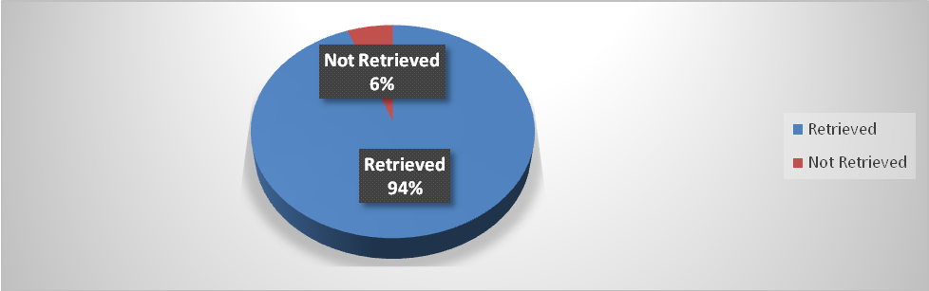
Source: Field Survey, 2023.
From the Figure above, a total of 300 copies of questionnaire were administered, out of which 283 responses were retrieved, representing 94% of the sample size, and found valid for the analysis.
Figure 2: Preferred Social Media Types
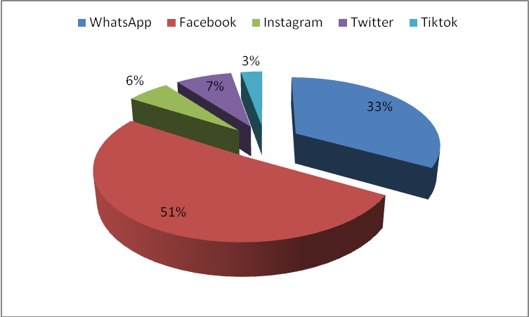
Source: Field Survey, 2023.
This implies that social media has become one of the platform for accessing health messages. The findings in the above Figure are not unconnected with the fact that Facebook and WhatsApp are among most used social media tools among people across the globe for searching for health messages and other information.

Figure 3: Awareness of Messages on WhatsApp, Facebook, Twitter, Tiktok and Instagram concerning Pneumonia
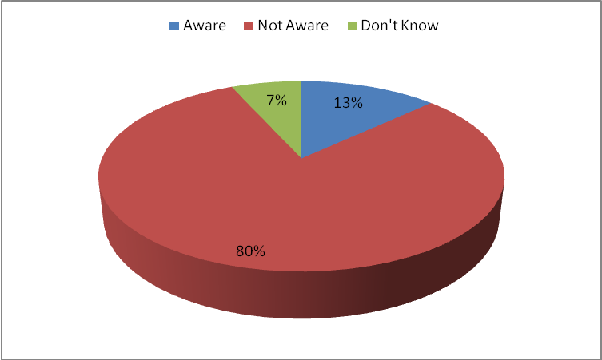
Source: Field Survey, 2023.
This implies that 226 respondents are not aware of the disease. It could thus be deduced from the above Figure that the social media as communication platforms has not done enough is disseminating information concerning pneumonia disease.

Table 1: Types of Pneumonia Messages Accessed from WhatsApp, Facebook, Twitter, Tiktok and Instagram
Option | Frequency | Percentage
It causes cough, fever, chills and difficulty in breathing | 2 | 3.5%
Messages on chest pain, confusion or changes in mental awareness | 4 | 7.0%
Fatigue, sweating and lower than normal body temperature | 1 | 1.7%
Nausea, vomiting or diarrhea | 1 | 1.7%
New born and infants may not show any sign of the infection | 4 | 7.0%
Get vaccinated | 2 | 3.5%
Make sure children get vaccinated | 1 | 1.7%
Practice good hygiene | 1 | 1.7%
Stop smoking | 2 | 3.5%
Keep your immune system strong by sleeping enough, doing exercises regularly and eating healthy diet | 4 | 7.0%
All of the above | 11 | 19.2%
None of the above | 24 | 42.1%
Total | 57 | 100%
Source: Field Survey, 2023.
Majority of the respondents (42.1%) indicated there has not been enough messages on social media regarding pneumonia. The implication of this that the disease may continue to affect people in Nigeria.

Figure 4: Frequency of Receiving Messages Concerning Pneumonia on WhatsApp, Facebook, Twitter, Tiktok and Instagram
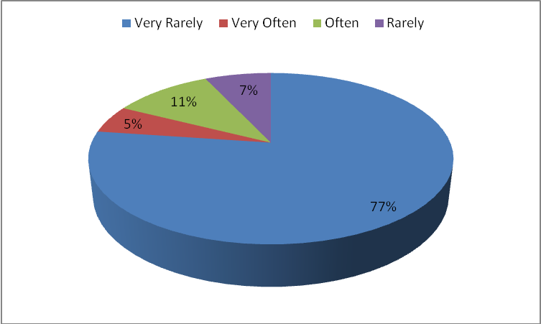
Source: Field Survey, 2023.
The finding above reveals that 44 (77%) of the respondents receive messages concerning pneumonia on whatsapp, facebook, twitter, tiktok and instagram on a very rare basis. The implication of this finding is that since the social media is able to reach a seasonable number of Nigerians with pneumonia-related messages, it can then be deduced that pneumonia prevention in Nigeria is possible through the use of social media platforms for campaign against the ailment. However, the social media need to do more.

Figure 5: Extent of Utilisation of Messages Received Regarding Pneumonia from WhatsApp, Facebook, Twitter, Tiktok and Instagram
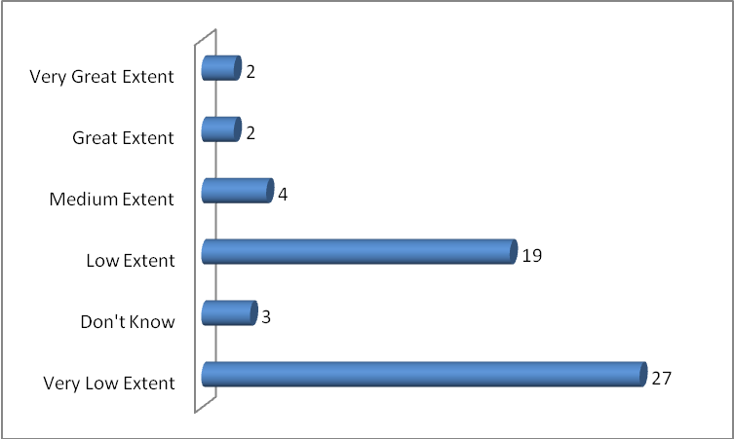
Source: Field Survey, 2023.
Finding above reveals that 27 of the respondents said that they use the messages on pneumia to a very low extent. The implication of this result is that pneumonia ailment may continue to increase in Nigeria if cogent steps are not taken to disseminate pneumonia-related messages on the social media.
Discussion of Findings
The discussion of findings was done according to the study objectives.
Research Objective One: Find out the types of social media residents of Jos South and North L.G.A. use to access health information: Data obtained from the respondents showed that the most used social media platforms are WhatsApp and Facebook. The finding is not far from the positions of Sasu (2022) that in the third quarter of 2022, WhatsApp was the most popular social media platform in Nigeria; it was mentioned by more than 95% of Internet users in the nation who are between the age of 16 to 64. Ossai (2022) supports that about 86.4% of Nigerians make use of the Facebook to access all forms of information, including health. Igwenagu (2023) further concurs that WhatsApp is the most dominant social media platform used by Nigerians, with more than 94%, followed by Facebook with 76%. The implication is that social media has become one of the platform for accessing health messages.
Research Objective Two: Examine the types of pneumonia messages they receive from the social media: Finding here revealed that the type of pneumonia messages that the respondents received from Facebook, WhatsApp, Tiktok, Twitter and Instagram include messages that pneumonia causes cough, fever, chills and difficulty in breathing, chest pain, confusion or changes in mental awareness, and fatigue. Others are sweating and lower than normal body temperature, nausea, vomiting or diarrhea and new born and infants may not show any sign of the infection. The study also revealed that the messages the respondents get from the studied social media include get vaccinated to prevent the disease, ensuring that children get vaccinated, practice good hygiene, stop smoking, and keep your immune system strong by sleeping enough, doing exercises regularly and eating healthy diet. Abuhashesh et al (2021) finding corroborates that there is a positive connection between messages from the social media and public awareness and adoption of the messages on health issues. Result further indicates that the respondents receive messages on pneumonia on very rare occasion. This finding is in line with research objective three. This finding negates the principles of the agenda setting theory, which postulate that the media's capacity to cause an issue to be elevated is importance in the mind of the public through repeated focus or coverage.
Research Objective Four: Investigate whether social media messages on pneumonia have improved their knowledge of preventing and managing the scourge: Finding here revealed that the respondents have been using the messages received from the studied social media on a very low extent. The finding agrees with that of Talipouo et al (2019). They found that despite the few people that have knowledge of the devastating impact of pneumonia, only few of them apply the information they receive from social media regarding pneumonia ailment. Ekure et al (2013) study further concur that 15% of the mothers in Lagos State had no knowledge of pneumonia.
Conclusion
The focus of the study is to investigate public perception of social media agenda setting on pneumonia ailment in Dadin Kowa, Zaramaganda, Rayfield and Bukuru in Jos South, and Babale, Tudun Wada, Laranto and Jenta Adamu in Jos North Local Government Areas of Plateau State, Nigeria. From the findings, the research concludes that the studied population use Facebook and WhatsApp more than any social media platforms get information regarging pneumonia. This conclusion is in line with objectives number one, which was formulated to out find out the types of social media residents of Jos South and North L.G.A. use to access health information. The study also concludes that the types of pneumonia messages the respondents receive from the social media are related to the causes, prevention and control of pneumonia. The conclusion is linked to objectives two of the study.
It is also concluded that the social media has not done enough to disseminate information on pneumonia disease. This conclusion aligns with objective three, crafted to assess the extent to which Jos South and North L.G.A. access messages on pneumonia on social media. Finally, the study concludes that the respondents use the messages concerning pneumonia they receive from the social media minimally. This conclusion is in line with objective four that set out to investigate whether social media messages on pneumonia have improved their knowledge of preventing and managing the scourge.
Recommendations
- Governments and its agencies should create social media platforms sorely for enlightening the people about the scourge of pneumonia.
- Since the social media is disseminating information about pneumonia, Nigerians should continue to make use of these platforms to prevent and control the scourge of pneumonia.

References
Abuhashesh, M.Y., Al-Dmour, H., Masa’deh, R., Salman, A., Al-Dmour, R., Boguszewicz Kreft, M. & AlAmaireh, Q.N. (2021). The role of social media in raising public health awareness during the pandemic covid-19: An international comparative study. Informatics, 8, 80. https://doi.org/10.3390/informatics8040080
Adams, S.L. & Anantatmula, V. (2010). Social and behavioural inﬂuences on team process. Proj. Manag. J., 41, 89–98.
Ahmad, A.R. & Murad, H.R. (2020). Social media’s impact on panic during the COVID-19 pandemic in Iraqi Kurdistan: An online questionnaire study. J. Med. Internet Res., 22, e19556.
Albarran, A.B. (2013). The social media industries. Routledge.
Alkhateeb, F. M., Clauson, K. A., & Latif, D. A. (2011). Pharmacist use of social media. International Journal of Pharmacy Practice, 19(2), 140-142.
Amannah, P. I., Onyebuchi, C. A., Obayi, P. M. O. & Anorue, L. I (2016). Newspaper coverage of agricultural policies and programmes of President Jonathan's administration (2011-2015). Gouni Journal of Management and Social Sciences, 4(2), 144-156.
Apuke, O. D. (2019). Another look at the possibilities and challenges of Citizen Journalism in Nigeria: A narrative review: International Journal of International Relations, Media and Mass Communication StudiesVol.5, No.1.
Batrinca, B. & Treleaven, P.C. (2015). Social media analytics: A survey of techniques, tools and platforms. Ai Soc. 30, 89–116.
Boyed, D. M, & Ellison, N. B. (2007). Social network sites: Definition, history, and scholarship. Journal of Computer-Mediated Communication, 13(1):210-230.
Bravo, C.A. & Hoffman-Goetz, L. (2016). Tweeting about prostate and testicular cancers: Do twitter conversations and the 2013 November Canada campaign objectives align? J. Cancer Educ. 31, 236–243.
British Lung Foundation, (2023). Pneumonia statistics. https://statistics.blf.org.uk/pneumonia
Brooks, W. A., Zaman, K., Goswami, D. et al (2021). The etiology of childhood pneumonia in Bangladesh. The Paediatric Infectious Disease Journal, 40(9), 79-90.
Centres for Disease Control and Prevention, (2021). Pneumonia. https://www.cdc.gov.dotw/pneumonia/index.html
City Population, (2023). Plateau State in Nigeria. https://citypopulation.de/en/nigeria/admin/NGA032_plateau/
Cleveland Clinic, (2022). Pneumonia. https://my.clevelandclinic,org/health/diseases/4471- pneumonia
Clinic Barcelona, (2021). Pneumonia causes 2.5 million deaths around the world each year. https://www.clinicbarcelona.org/en/news/pneumonia-causes-2-5-million-deaths- around-the-world-each-year
Colineau, N. & Paris, C. (2010). Talking about your health to strangers: Understanding the use of online social networks by patients. N. Rev. Hypermedia Multimed, 16, 141– 160.
Collins, R. L. Elliott, M.N., Berry, S.H., Canouse, D.E, and Hunter, S.B. (2003). Entertainment television as a healthy sex educator: The impact of condom-efficacy information in an episode of friends. Pediatrics, 112(5), 1115-21.
Dredze, M. (2012). How social media will change public health. IEEE Intell. Syst., 27, 81– 84.
Dubey, R.K., Tripathi, V., Dubey, P.K., Singh, H.B. & Abhilash, P.C. (2016). Exploring rhizospheric interactions for agricultural sustainability: The need of integrative research on multi-trophic interactions. J. Clean. Prod, 115, 362–365.
Ekure, E. N., Esezobor, C. I., Balogun, M. R., Mukhtar-Yola, M., Ojo, O. O., Emodi, I. J., Omoigberale, A. I., Oviawe, O., Ezechukwu, C. C., Olowu, A. O., Ogala, W. N. & Esangbedo, D. O, (2013). Mothers and childhood pneumonia: What should the focus of public campaigns be? Niger J Paed, 40 (1), 24 –29.
Evans, D. (2011). Introduction to Computing: Explorations in Language, Logic, and Machines. Richmond, VA: Creative Common.
Farmer, A., Holt, C., Cook, M., & Hearing, S. (2020). Social networking sites: A novel portal for communication. Postgrad. Med. J., 85, 455–459.
Gaille, L. (2020). 20 advantages and disadvantages of survey research. https://vittana,org/20- advantages-and-disadvantages-of-survey-research
Goldstein, K., Briggs, M., Oleynik, V., Cullen, M., Jones, J., Newman, E. & Narva, A. (2013). Using digital media to promote kidney disease education. Adv Chronic Kidney Dis. 20(4), 364–369. doi:10.1053/j.ackd.2013.04.001
Hazzam, J., &Lahrech, A. (2018). Health care professionals social media behaviour and the underlying factors of social media adoption and use: Quantitative study. Journal of Medical Internet Research, 20(11), e12035.
Igenagu, E. (2023). Leading social media platforms in Nigeria. https://nigeriainformer.com/most-used-social-media-in-nigeria/
Jane, M., Hagger, M., Foster, J., Ho, S., & Pal, S. (2018). Social media for health promotion and weight management: A critical debate. BMC public health, 18(1), 932.
Jones, T. L., Baxter, M. A. J. & Khanduja, V. (2013). A quick guide to survey research. Ann R Coll Surg Engl., 95(1), 5-7.
Kallander, K., Hildenwall, H., Waiswa, P., Galiwango, E., Peterson, S. & Pariyo, G. (2008). Delayed care seeking for fatal pneumonia in children aged under five years in Uganda: a case-series study. Bull World Health Organ, 86(5), 332-8.
Kaplan, A. M., & Haenlein, M. (2010). Users of the world, unite! The challenges and opportunities of Social Media. Business Horizons, 53(1), 59–68.
Koivimaki, T., Ristola, A., Kesti, M. (2007). The perceptions towards mobile services: An empirical analysis of the role of use facilitators. Personal and Ubiquitous Computing, 12(1), 67-75.
La, V.P., Pham, T.H., Ho, M.T., Nguyen, M.H., Nguyen, K.L.P., Vuong, T.T., Tran, T., Khuc, Q., Ho, M.T. & Vuong, Q.H.(2020). Policy response, social media and science journalism for the sustainability of the public health system amid the COVID-19 outbreak: The Vietnam lessons. Sustainability, 12, 2931.
Laranjo, L., Arguel, A., Neves, A.L., Gallagher, A.M., Kaplan, R., Mortimer, N., Mendes, G.A. & Lau, A.Y. (2015). The inﬂuence of social networking sites on health behaviour change: A systematic review and meta-analysis. J. Am. Med. Inform. Assoc., 22, 243–256.
Lippert, J. F., Buscemi, J., Saiyed, N., Silva, A. & Benjamins, M. R. (2022). Influenza and pneumonia mortality across the 30 biggest U.S. cities: Assessment of overall trends and racial inequalities. J. Racial Ethn Health Disparities, 9(4), 1152-1160.
Machuki, J. A., Omondi, D. S., Omondi, A. A. B. & Onono, M. A. (2019). Patient-level cost of home-and facility-based child pneumonia treatment in Suba Sub county, Kenya. PLOS One, 14(11), e0225194.
Majali, T., Alsoud, M., Omar, A. & Alhassan, I. (2021). Social media use as health awareness tool: a study among healthcare practitioners. Multicultural Education, 7(2).
Mariam, A., J., A., Nurazmallail, M., & Miftachul, H. (2020). Examining information accuracy on social media: Empirical evident from United Arab Emirates (UAE): Journal of Critical Reviews ISSN- 2394-5125.
Mayo Clinic, (2020). Overview of pneumonia and your lungs. https://www.mayoclinic,org/diseases-conditions/pneumonia/symptoms-causes/syc- 20354204
Merchant, R. M., & Lurie, N. (2020). Social media and emergency preparedness in response to novel coronavirus. JAMA, 323, 2011–2012.
Mohammed, W., Alanzia, T., Alanezib,F., Alhodaibc, H., & AlShammarid, M. (2021). Usage of social media for health awareness purposes among health educators and students in Saudi Arabia. Informatics in Medicine Unlocked. https://doi.org/10.1016/j.imu.2021.100553
Moorhead, S., Hazlett, D., Harrison, L., Carroll, J., Irwin, A. & Hoving, C. (2013). A new dimension of health care: Systematic review of the uses, beneﬁts, and limitations of social media for health communication. J. Med. Internet Res. 15, e85.
Muanya, C. (2020, November 12). 160, 000 Nigerian children die if pneumonia yearly. The Guardian, https://guardian.ng/news/160000-nigeria-children-die-of-pneumonia-yearl/
News Medical and Life Sciences, (2023). Analysis reveals highest number of pneumonia deaths in the UK. https://www.news-medical.net/news/20221110/Analysis-reveals- highest-number-of-pneumonia-deaths-in-the-UK.aspx
News Medical and Life Sciences, (2023). Pneumonia history. https://www.news- medical.net/healtj/Pneumonia-History.aspx
Office of National Statistics, (2021). Census 2021, data and analysis from census 2021. https://www.ons.gov.uk/aboutus.transparencyandgovernance/freedomofinformationfo i/ukpneumoniadeaths2020and2021
Ossai, N. (2022). Top 10 most used social media in Nigeria. https://www.skabash.com/most- used-social-media-in-nigeria/
Salathe, M. (2016). Digital pharmacovigilance and disease surveillance: Combining traditional and big-data systems for better public health. J. Infect. Dis.214 (4), S399– S403.
Sánchez-Moya, A., & Cruz-Moya, O. (2015). Whatsapp, textese, and moral panics: discourse features and habits across two generations. Procedia-Social and Behavioural Sciences, 173, 300-306.
Schwab, K. (2015). The fourth industrial revolution - What it means and how to respond. Snapshot.
Sharma, K. (2023, January 23). Why pneumonia cases are on rise and how you can identify it on time. E Times, https://m.timesofindia.com/life-style/health-fitness/health- news/why- pneumonia- cases-are-on-rise-symptoms- prevention/photostory/97242937.cms
Shaw, T., McGregor, D., Brunner, M., Keep, M., Janssen, A., & Barnet, S. (2017). What is eHealth (6)? Development of a conceptual model for eHealth: qualitative study with key informants. Journal of Medical Internet Research, 19(10), e324.
Shrank, W. H. (2011). Variations in structure and content of online social networks for patients with diabetes. Arch. Intern. Med. 171, 1589–1591.
Talipouo et al. (2019). “Malaria prevention in the city of Yaounde: Knowledge and practices of urban dwellers”. Malaria Journal, 18:167, https://doi.org/10.1186/s12936-019- 2799-6.
The Star Online. (2019). An outlook on the Malaysian healthcare scene for 2019. https://www.star2.com/health/2019/01/09/malaysian-healthcare-scene-2019/
Tornheim, J. A., Manya, A. S., Oyando, N., Kabaka, S., Breiman, R. F. & Frikin, D. R. (2007). The epidemiology of hospitalised pneumonia in rural Kenya: The potential of surveillance data in setting public health priorities. International Journal of Infectious Diseases, 11(6), 536-543.
UNICEF, (2019). Nigeria contributes highest number to global pneumonia child deaths. https://www.unicef.org/nigeria/press-release/nigeria-contributes-highest-number- global-pneumonia-child-deahts
UNICEF, (2022). Pneumonia. A child dies of pneumonia every 43 seconds. https://data.unicef.org/topic/child-health/pneumonia/
USAID. (2006). Avian influenza: Media orientation training notes. USAID: From the American People.
Venkatesh, V., Morris, M. G., Davis, G. B. & Davis, F. D. (2003). Use acceptance of information technology: Toward a unified view. MIS Quarterly, 27(3), 425-478.
Wong, C.A., Merchant, R.M. & Moreno, M.A. (2014). Using social media to engage adolescents and young adults with their health. In Healthcare; Elsevier: Amsterdam, The Netherlands, 2, 220–224.
World Health Organisation, (2022). Pneumonia in children. https://www.who.int/news- room/fact-sheets/details/pneumonia
Yigitcanlar, T., Kankanamge, N., Preston, A., Gill, P., Rezayee, M., Ostadnia, M., Xia, B. & Ioppolo, G.(2020). How can social media analytics assist authorities in pandemic related policy decisions? Insights from Australian states and territories. Health Inf. Sci. Syst., 8, 37.

